Nanosytems for conservation of Cultural Heritage
Piero Baglioni
Department of Chemistry& CSGI, University of Florence, Via della Lastruccia 3 - Sesto Fiorentino, 50019 Florence, Italy.
baglioni@csgi.unifi.it
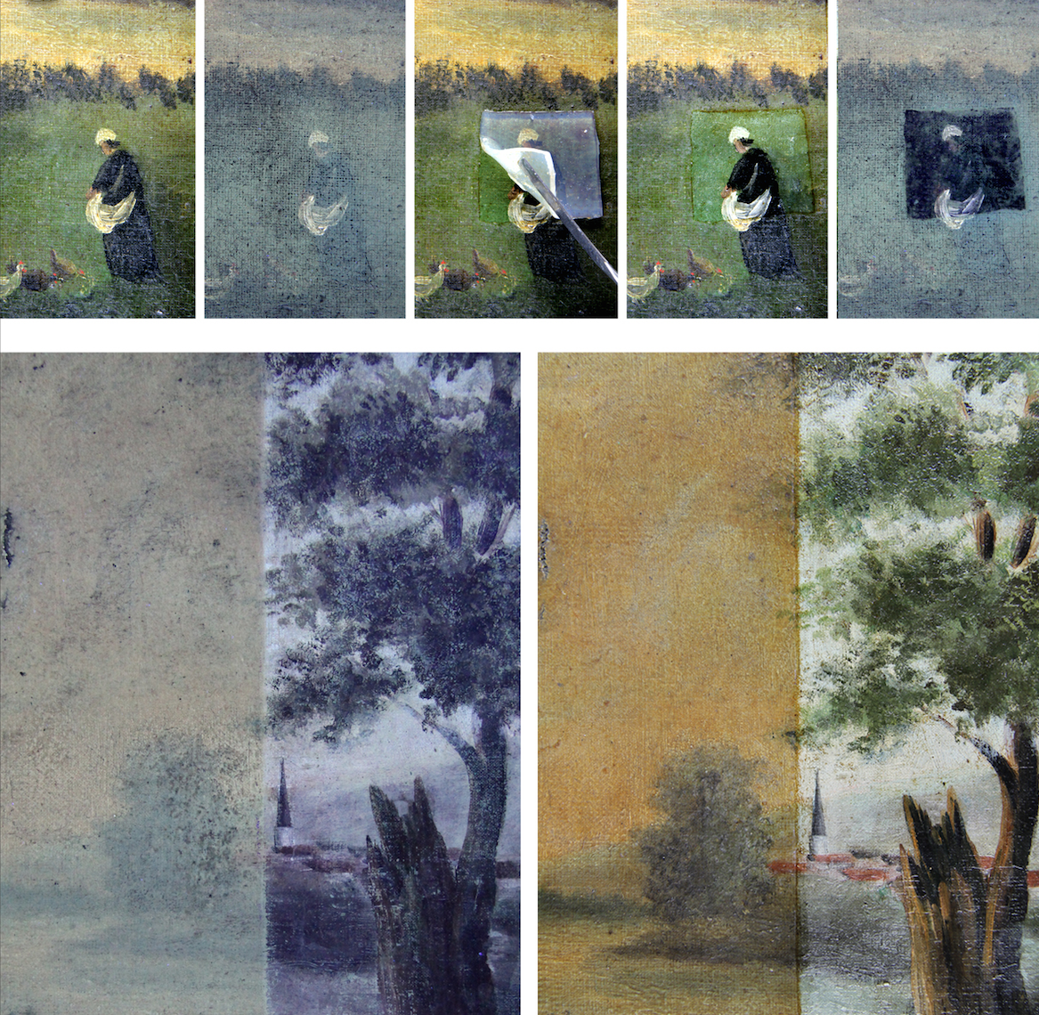
Abstract: Works of art and artifacts that constitute our cultural heritage are subject to deterioration. Their surfaces interacting with the environment are the most prone to aging and decay; accordingly, soiling is a prime factor in the degradation of surfaces, chemical and mechanical degradation are often associated to soiling and lead to the disfigurement of a piece of art. The effects of these processes are usually strongly amplified in the presence of protective coatings (mainly acrylic and vinyl polymers), often applied in previous restoration treatments. In the past years we pioneered the synthesis and the application of several advanced systems for the consolidation and the cleaning of works of art, as hydroxides nanoparticles, microemulsions and chemical/physical gels. In this talk examples from i) paintings consolidation using nanoparticles fully compatible with the artifacts, ii) self assembled systems for the cleaning or the removal of coatings from pictorial surfaces will be highlighted. Micellar solutions and microemulsions constitute very efficient systems for the removal of acrylic, vinyl and alkyd polymers or grime/soil. These systems (as well as neat solvents used in "traditional" conservation) can be confined into chemical and physical gels having proper nano-domains for the upload or the delivery of compounds from/to the work of art. For example, a fine control of the cleaning procedure can be obtained even for challenging cleanings as water sensitive works of art, where the cleaning can be achieved by using water confined into gels, and leaving no residues on the works of art.
Keywords: Nanoparticles, Micelle, Microemulsions, Physical Gel, Chemical Gel, Consolidation, Cleaning, Wall Paintings, Easel Paintings
References
1) P. Baglioni, E. Carretti, D. Chelazzi. Nanomaterials in art conservation. Nature Nanotechnology 10, 287-290, 2015.
2) P. Baglioni, D. Chelazzi, R. Giorgi. Nanotechnologies in the Conservation of Cultural Heritage - A compendium of materials and techniques, Springer 2015
3) P. Baglioni, D. Chelazzi. Nanoscience for the Conservation of Works of Art, Royal Society of Chemistry, 2013.
4) D. Chelazzi, G. Poggi, Y.Jaidar, N. Toccafondi, R. Giorgi, P. Baglioni. Hydroxide nanoparticles for cultural heritage: Consolidation and protection of wall paintings and carbonate materials. Journal Colloid Interface Sci. 2013, 392, 42–49.
5) NANOMATERIALS TO PRESERVE ANCIENT WORKS OF ART, Research*EUresults magazine N°37 / November 2014, PAGE 7; http://cordis.europa.eu/project/rcn/101376_en.html

